COS40007 – Artificial Intelligence Engineering
Applied Project Task 2 (Group Task 2)
Implement a GitHub Actions Trigger
Project: Anti-Spoofing for Secure Login – Edge Liveness Detection on Raspberry Pi
Item | Details
Unit | COS40007 Artificial Intelligence Engineering
Task | Group Task 2 – Studio Activity 7 (Week 7)
Group No. | 3
Group members | Dinh Phu Nguyen – 105027282; Phuc Lam Nguyen – 105006540
Submission date | 11/08/2026
GitHub repository | https://github.com/phu1009/COS40007---AI-Engineering-

Pipeline overview
We added a basic machine-learning pipeline to our group repository with GitHub Actions. Every push to main (and every pull request to main, or a manual run) starts a GitHub-hosted ubuntu-latest runner that installs our dependencies, runs our project training script model.py, and uploads the results as downloadable artefacts.
git push (or pull request to main / Run workflow button)
↓
GitHub Actions triggered → workflow 'Train ML Model' (.github/workflows/train.yml)
↓
ubuntu-latest runner spins up
↓
checkout code → set up Python 3.11 → cache pip → install requirements.txt
↓
python model.py
→ builds a live / print-attack / replay-attack face dataset, subject-disjoint split
→ trains a lightweight CNN anti-spoofing (PAD) model
→ saves model_results.png, metrics.txt and pad_model.keras
↓
upload artefact 'model-results' (downloadable from the Actions UI)
model.py is our project file. It trains the face presentation-attack-detection model from our Task 1 blueprint: a small depthwise-separable CNN (MiniFASNet-style, light enough for a Raspberry Pi) that outputs a live score. The threshold is chosen on validation data (BPCER ≤ 5 %) and the test set is scored with the ISO/IEC 30107-3 metrics APCER, BPCER and ACER, plus accuracy and ROC-AUC. The real datasets (CelebA-Spoof, Replay-Attack) are licensed and tens of GB, so they cannot be downloaded inside CI; the script therefore generates a small synthetic stand-in with the same three classes. Training takes about 30 seconds and the whole run about one minute, which keeps the pipeline simple, as the brief asks.

1. Repository & File Structure
The repository contains exactly the required structure at the root of the group repository:
COS40007---AI-Engineering-/ (group repository)
├── .github/
│ └── workflows/
│ └── train.yml ← pipeline definition
├── model.py ← project training script
├── requirements.txt ← dependencies
├── README.md ← pipeline description + status badge
├── Group Project/ ← Task 1 documents and project code
└── Portfolio Assessment 1–3/
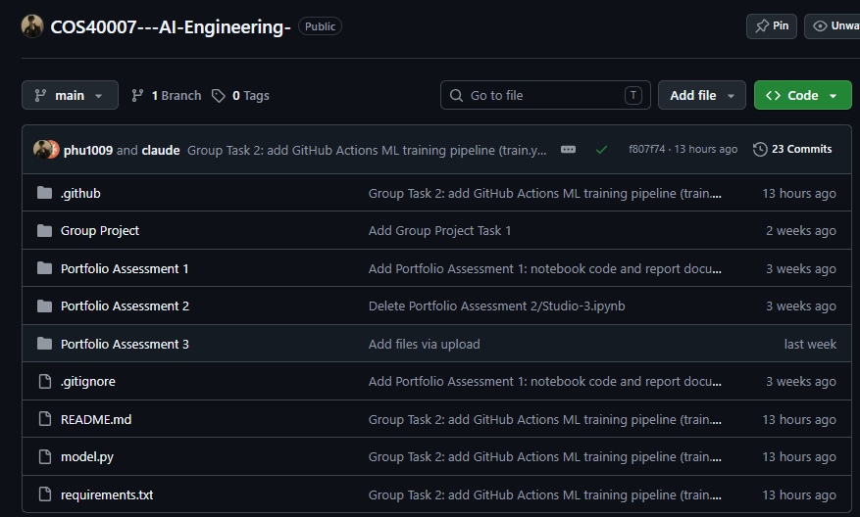
Figure 1. Repository root on GitHub showing .github, model.py, requirements.txt and README.md (https://github.com/phu1009/COS40007---AI-Engineering-).
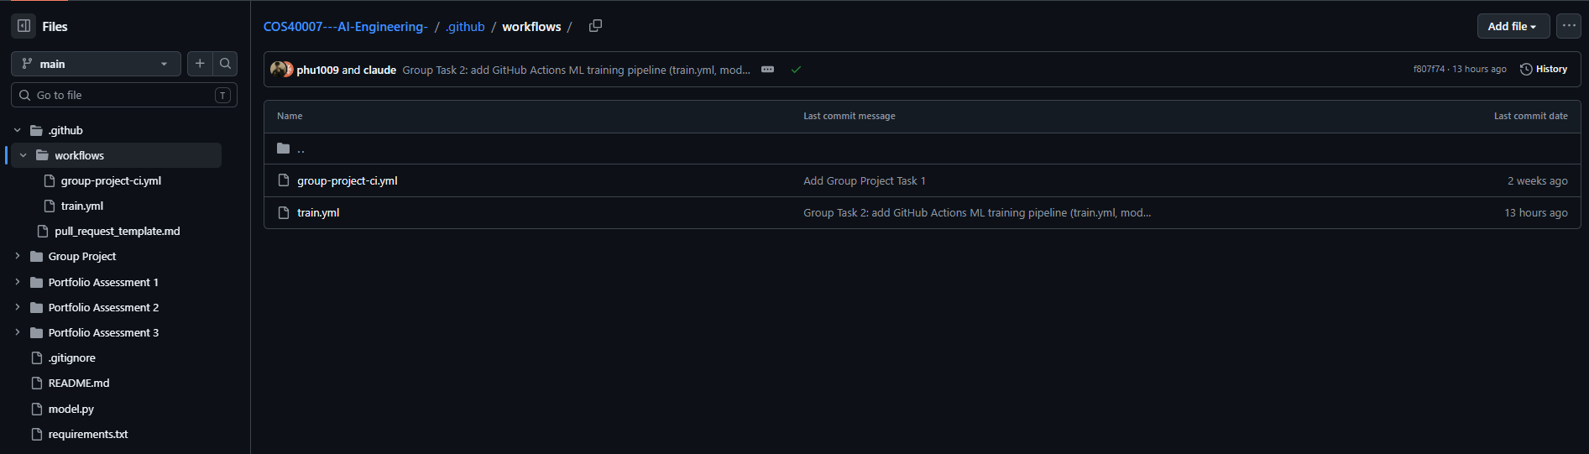
Figure 2. The workflow file in the exact required location .github/workflows/train.yml (https://github.com/phu1009/COS40007---AI-Engineering-/tree/main/.github/workflows).

2. requirements.txt
tensorflow==2.21.0
numpy==2.4.6
matplotlib==3.11.2
- All three required libraries are listed with correct package names: tensorflow, numpy, matplotlib.
- Versions are pinned so every run installs the same environment: TensorFlow 2.21.0 (the version given in the Studio guide) supports the runner's Python 3.11, and the NumPy and Matplotlib versions were installed and tested together with it (pip check: no broken requirements).
- Changing this file also changes the pip cache key in train.yml, so the cache is refreshed automatically.
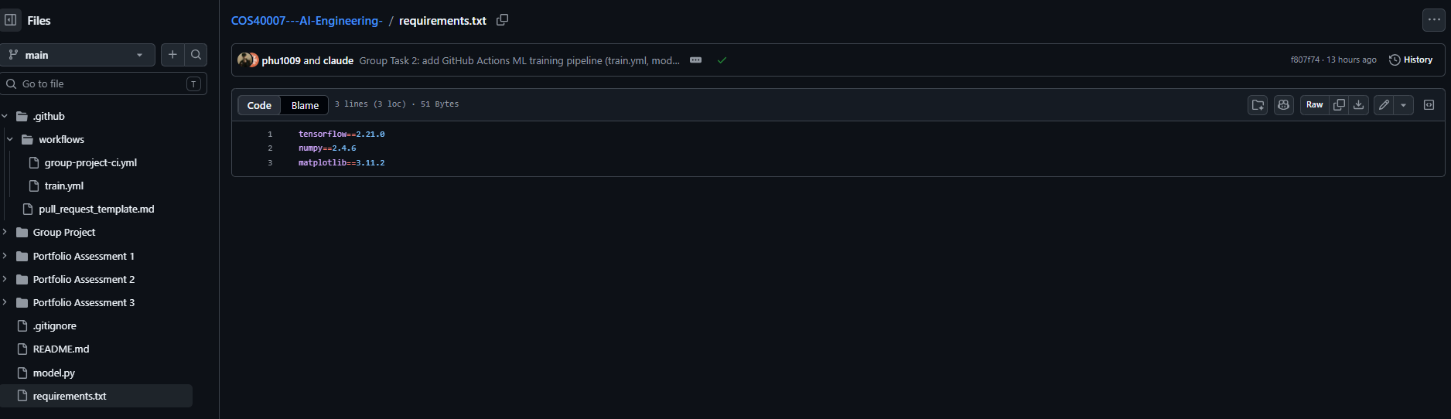
Figure 3. requirements.txt in the repository root (https://github.com/phu1009/COS40007---AI-Engineering-/blob/main/requirements.txt).

3. Workflow Triggers (on:)
name: Train ML Model

on:
push:
branches: [ main ] # runs every time we push to main
pull_request:
branches: [ main ] # runs on pull requests to main
workflow_dispatch: # allows a manual run from the GitHub Actions UI
Trigger | When the pipeline runs
push → branches: [ main ] | Every time a commit is pushed to main.
pull_request → branches: [ main ] | Every time a pull request targeting main is opened or updated, so changes are tested before merging.
workflow_dispatch | Manual run from the GitHub UI: Actions → Train ML Model → Run workflow.
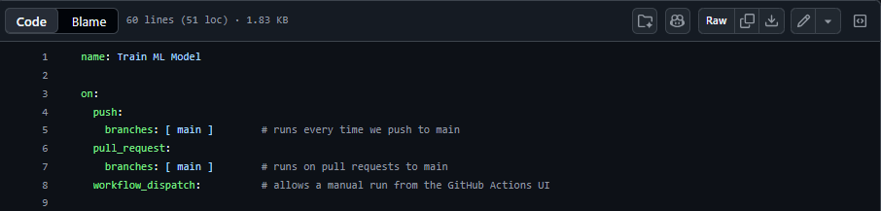
Figure 4. train.yml – workflow name and the three triggers (https://github.com/phu1009/COS40007---AI-Engineering-/blob/main/.github/workflows/train.yml).

4. Pipeline Job Definition
The workflow defines one job named train that runs on the GitHub-hosted ubuntu-latest runner and executes the required steps in order:
# | Step | What it does
1 | Checkout code | actions/checkout@v4 – copies the repository onto the runner.
2 | Set up Python | actions/setup-python@v5 – installs Python 3.11.
3 | Cache pip dependencies | actions/cache@v4 – caches ~/.cache/pip, keyed on the hash of requirements.txt, so repeat runs install faster.
4 | Install dependencies | pip install -r requirements.txt
5 | Train model | python model.py – trains the anti-spoofing model and writes the result files.
6 | Upload results | actions/upload-artifact@v4 – uploads model_results.png, metrics.txt and pad_model.keras as the artefact 'model-results'; fails the run if a file is missing.
7 | Show metrics in run summary | Extra step: prints metrics.txt on the run's summary page.

jobs:
train:
runs-on: ubuntu-latest # GitHub-hosted Linux runner (free)

steps:
# 1. Check out the repository code
- name: Checkout code
uses: actions/checkout@v4

# 2. Set up Python
- name: Set up Python
uses: actions/setup-python@v5
with:
python-version: '3.11'

# 3. Cache pip packages so repeat runs are faster
- name: Cache pip dependencies
uses: actions/cache@v4
with:
path: ~/.cache/pip
key: ${{ runner.os }}-pip-${{ hashFiles('requirements.txt') }}
restore-keys: |
${{ runner.os }}-pip-

# 4. Install dependencies from requirements.txt
- name: Install dependencies
run: pip install -r requirements.txt

# 5. Train the anti-spoofing (PAD) model - runs model.py
- name: Train model
run: python model.py

# 6. Upload the plot, metrics and trained model as artefacts
# so they can be downloaded from the GitHub Actions UI
- name: Upload results
uses: actions/upload-artifact@v4
with:
name: model-results
path: |
model_results.png
metrics.txt
pad_model.keras
if-no-files-found: error

# 7. Show the metrics on the run's summary page
- name: Show metrics in run summary
run: |
echo '### Group 3 - Anti-Spoofing model metrics' >> "$GITHUB_STEP_SUMMARY"
echo '```' >> "$GITHUB_STEP_SUMMARY"
cat metrics.txt >> "$GITHUB_STEP_SUMMARY"
echo '```' >> "$GITHUB_STEP_SUMMARY"
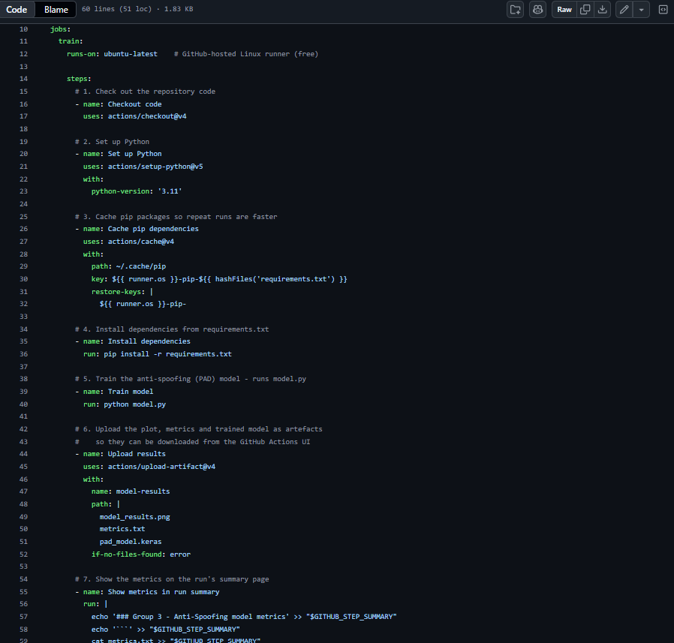
Figure 5. train.yml – job 'train' on ubuntu-latest with the sequential steps.

5. Successful Pipeline Execution
The pipeline ran to completion without errors on all four runs: runs #1, #2 and #4 were triggered by git push and run #3 was started manually (workflow_dispatch); each took about one minute (Figure 11). Figures 6–7 show run #3. Every step – checkout, Python set-up, cache, install, training and upload – shows a green check mark. The only annotation is a GitHub platform warning that actions built for Node.js 20 now run on Node.js 24; it does not affect the run, and we keep actions/upload-artifact@v4 as specified.
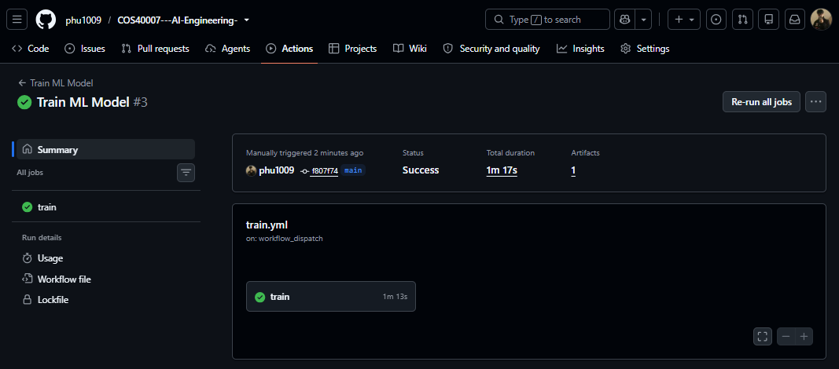
Figure 6. Run summary: status Success, job 'train' passed, artefact listed (https://github.com/phu1009/COS40007---AI-Engineering-/actions/runs/42494208816).
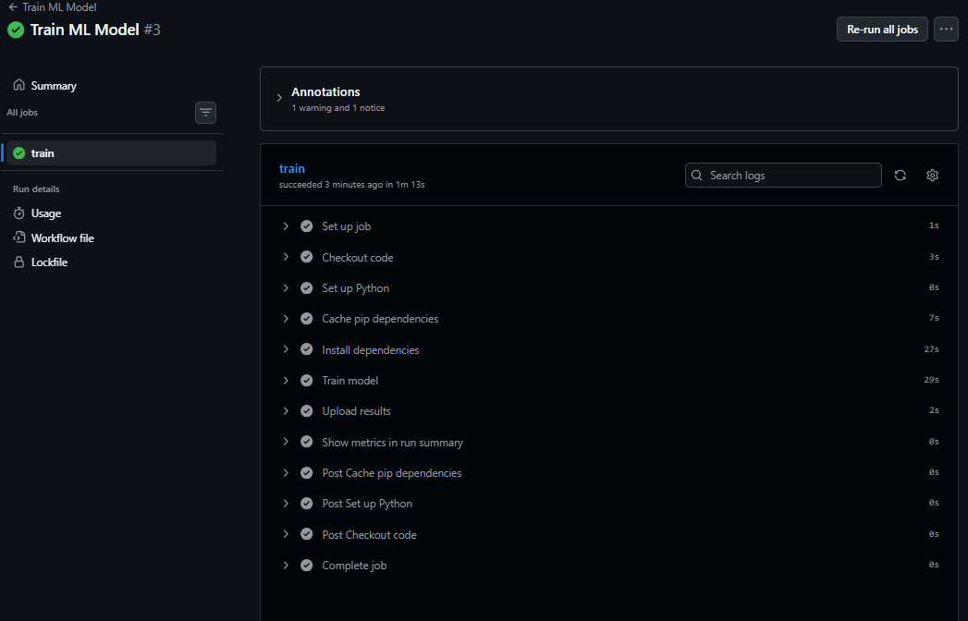
Figure 7. Job log: all steps of job 'train' completed with green check marks (https://github.com/phu1009/COS40007---AI-Engineering-/actions/runs/42494208816/job/128772869873).

6. Artefact Generation & Upload
model.py generates the results files and the workflow uploads them with actions/upload-artifact@v4 under the name model-results:
File | Content
model_results.png | Six panels: test samples (live / print / replay), loss and ROC-AUC per epoch, ROC curve with the chosen operating point, score distribution per class, confusion matrix.
metrics.txt | Run number, commit, TensorFlow version, data split, threshold, APCER per attack type, BPCER, ACER, accuracy and ROC-AUC.
pad_model.keras | The trained model, ready for later conversion to ONNX/TFLite for the Raspberry Pi.
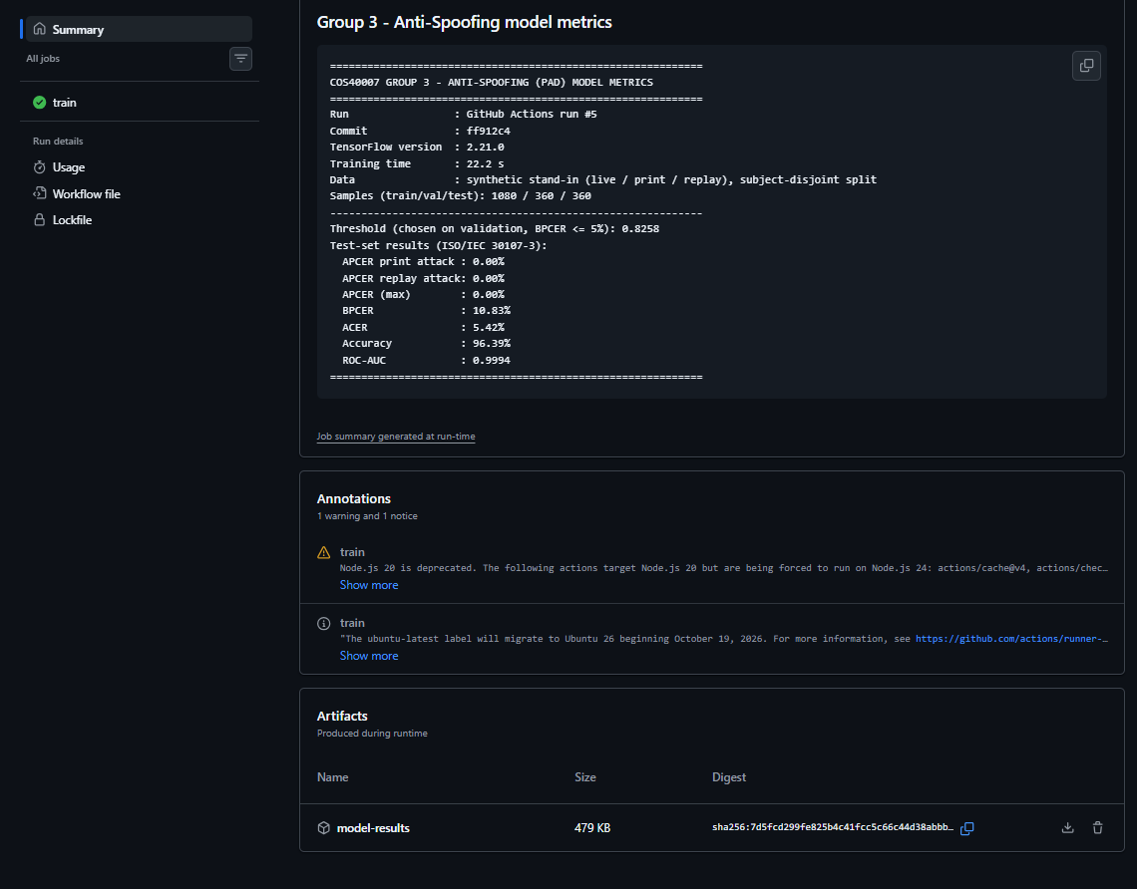
Figure 8. Artifacts section of the run: 'model-results' available for download.
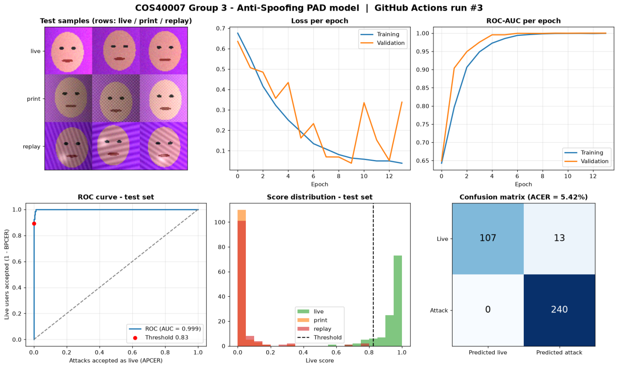
Figure 9. Downloaded artefact: model_results.png produced by the pipeline.
Content of the downloaded metrics.txt:
============================================================
COS40007 GROUP 3 - ANTI-SPOOFING (PAD) MODEL METRICS
============================================================
Run : GitHub Actions run #3
Commit : f807f74
TensorFlow version : 2.21.0
Training time : 22.8 s
Data : synthetic stand-in (live / print / replay), subject-disjoint split
Samples (train/val/test): 1080 / 360 / 360
------------------------------------------------------------
Threshold (chosen on validation, BPCER <= 5%): 0.8258
Test-set results (ISO/IEC 30107-3):
APCER print attack : 0.00%
APCER replay attack: 0.00%
APCER (max) : 0.00%
BPCER : 10.83%
ACER : 5.42%
Accuracy : 96.39%
ROC-AUC : 0.9994
============================================================

7. Demonstration of Functionality
We demonstrated the full cycle: trigger the pipeline with git push, find the run in the GitHub Actions UI, and download the artefacts.

7.1 Trigger with git push
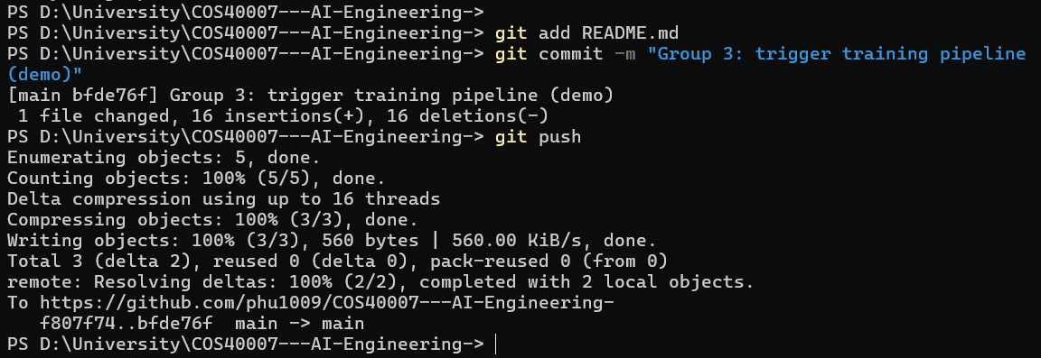
Figure 10. Terminal: commit and git push to main, which triggers the workflow.

7.2 Locate the run in the GitHub Actions UI
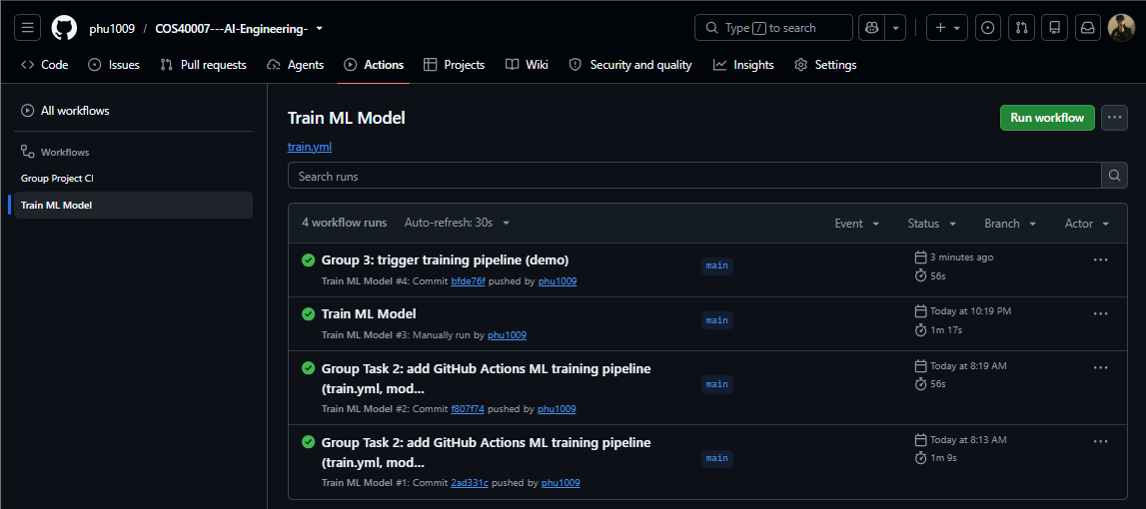
Figure 11. Actions tab → 'Train ML Model': the runs started by push (and by the manual trigger) (https://github.com/phu1009/COS40007---AI-Engineering-/actions/workflows/train.yml).

7.3 Manual trigger (workflow_dispatch)
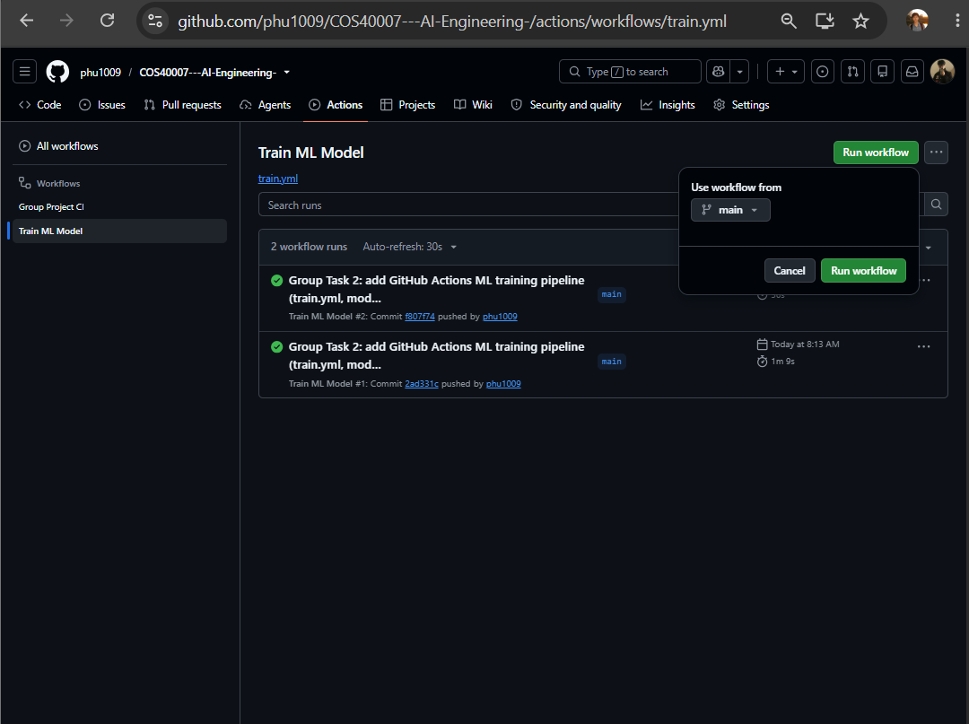
Figure 12. Run workflow button on the 'Train ML Model' page, used to start the pipeline manually.

7.4 Download the artefacts
Open the finished run → scroll to Artifacts → click model-results to download a zip containing model_results.png, metrics.txt and pad_model.keras (Figures 8–9 show the downloaded files).

8. GitHub Link
Group repository:
https://github.com/phu1009/COS40007---AI-Engineering-
Workflow (Actions):
https://github.com/phu1009/COS40007---AI-Engineering-/actions/workflows/train.yml
Workflow file:
https://github.com/phu1009/COS40007---AI-Engineering-/blob/main/.github/workflows/train.yml

